Date form handed in to Practice………………
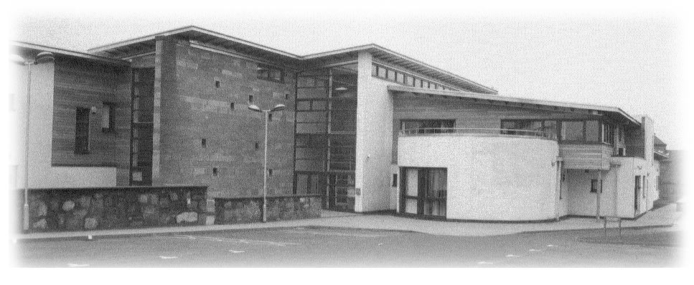
Dr Sutherland, Wheater, Ledlie & Forrester
West Practice
Springfield Medical Centre
30 Ponderlaw St, Arbroath
DD11 1ES
Tel 01241 870307

GOING ABROAD ON HOLIDAY OR BUSINESS ?

You may need travel vaccinations, depending on the country or countries that you intend to visit.
To help us advise you on the protection you need, complete this form and return it at least 8 weeks before you travel. This will allow us to work out your requirements and offer you an appointment schedule for vaccinations. Please note that not all vaccinations are provided on the NHS and charges may apply in certain instances.

Please note one form per traveller.
Name

Address

Telephone No.

Date of Birth

1. Which countries & specific areas do you intend to visit (including brief stopovers)?
Country | Area |  | Length of stay
2. Will you be staying in hotels or under more primitive conditions (e.g. camping)?
For travel within the next 6 weeks we may not be able to provide a travel service and you may be required to make alternative arrangements.
PATIENT QUESTIONNAIRE
PRIVATE AND CONFIDENTIAL

3. Do you plan any climbing safaris, jungle exploration or travel in difficult terrain? If so please explain more.
4. Departure Date
9. Have you ever had any of the following vaccinations and if so when?
Date
Hep B
Typhoid
Tetanus
Hepatitis A
Yellow Fever
Polio
Diphtheria
Others

6. Are you allergic to anything?
7. Are you on any medications?
8 Have you ever had or are you suffering from heart disease or other chronic illness?

 | Yes |  |  | No
4. Are you Pregnant?

Remember: if you are receiving any medication, make sure that you take enough supplies to last through your overseas visit.

PRACTICE INFORMATION ON REVERSE
THIS SIDE FOR PRACTICE USE ONLY

Part III: DISCUSS THE FOLLOWING WITH THE TRAVELLER:

Have you ever had a reaction to any medicine used to prevent malaria? Yes/No
Have you ever been treated for depression or ever seen your doctor about depression Yes/No
Have you ever been treated for or suffered from an anxiety state? Yes/No
Have you ever had a fit or convulsion? Yes/No
Do you have any problems with your heart, kidneys or your liver? Yes/No
Do you have psoriasis? Yes/No
Are you pregnant or is there a possibility that you could be pregnant Yes/No
or may become pregnant within 3 months of the trip?
Are you currently breast-feeding your baby? Yes/No

RECOMMENDED VACCINES

Vaccination | ✓Required | Date Given | Charge | Vaccination | ✓Required | Date Given | Charge
Hep A Primary |  |  |  | Malaria Proph |  |  | £
Booster
Typhoid
Diptheria & Tetanus & Polio 1
2
3 |  |  |  | Other
Booster |  |  |  | Private Prescription Issued |  |  | £
 |  |  |  | Date Paid |  |  | £

JAPANESE B ENCEPHALITIS, TIC BORNE ENCEPHALITIS
YELLOW FEVER, HEPATITIS B, MENINGOCOCCAL Refer to MASTA

BCG Refer to Chest Clinic, N/W

DOCTORS SIGNATURE ……………………………………………………DATE……………………………

I have received and understood the advice given
to me concerning:
 | Travel vaccination requirements
 | Anti-malarial prophylaxis
 | General preventative measures (see protocol)
 | For myself |  | For my child
 | Leaflet given
and consent to the administration of the vaccinations identified above.

Signature………………………………………..

Date……………………………………………..

Completed by ………………………………….. (to be signed by Practice Nurse administering vaccines and travel advice)

23-Nov-26
/tmp/lo/0000.doc

Charges for Travel

Please note that certain vaccines are not available on the NHS and, therefore, where these vaccinations are required a fee will be made.

Fee for a Private Prescription £15.00
Fee for a course of vaccinations £33.00

The Chemist will also charge for the cost of the drugs as well as a dispensing fee.

